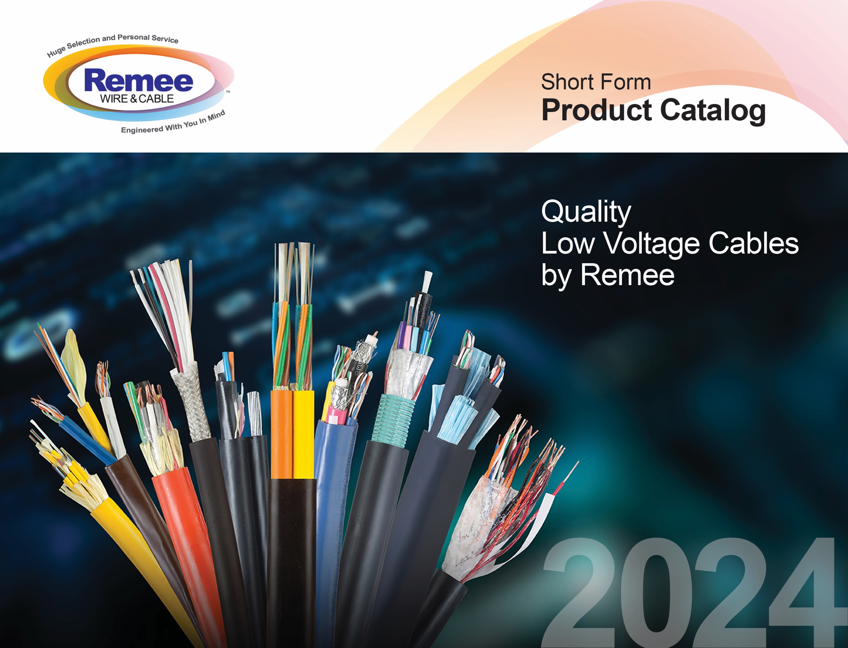
T it

2024
CATALOG

SECURITY & ALARM CABLE ⚫ FIRE ALARM CABLE ⚫ CATEGORY CABLE
COAXIAL CABLE ⚫ ACCESS CONTROL CABLE ⚫ SPEAKER WIRE ⚫ PV WIRE
WET LOCATION COPPER CABLE ⚫ THERMOSTAT CONTROL CABLE

SECTION | PAGE
Renewables™ by Remee – PV Wire, Fiber Optic Cable, Ground Wire | 3
Vigilance™ Series
Access Control Cable | 5
Security & Alarm Cable | 7
Fire Alarm Cable | 10
 | 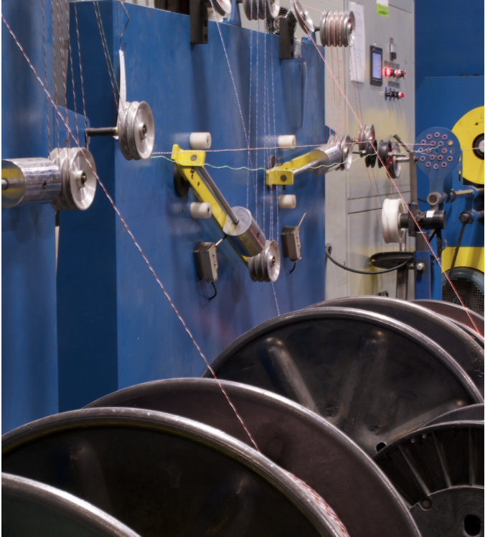
Thermostat Cable | 13
Fiber Optic Cable | 15
Distribution, Indoor/Outdoor, OFNP/OFCP | 16
Central Loose Tube Armored, OSP | 17
LAN & Premise (Category) Cable | 18
High-Strand Pro Audio & Speaker Cable | 20
Wet Location Cable | 22
Coaxial Cable | 24
Color Coding Chart | 26
Notes | 27

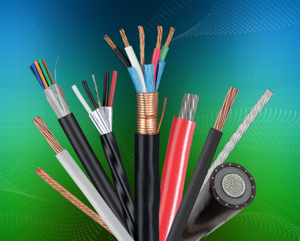
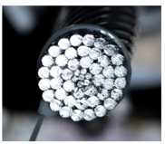
- Solar Array Cables - Copper PV wire rated at 2000V with cross-linked polyethylene (XLPE) jackets for durability.

- DC Feeder Cables - Aluminum PV wire rated at 2000V, also with cross-linked polyethylene (XLPE) jackets for durability.
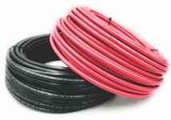
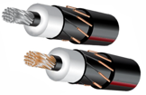
- Fiber Optic Cables - Interference-free
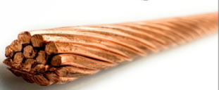
Fiber Optic cables are available with loose tube construction featuring Remee’s gel-free AquaLock™ design; available with and without armor. Fiber optic cables in duct are available.

- Bare Stranded Copper Ground Wire Common sizes are available upon request.

Photovoltaic Wire XLPE Insulation – 2kV Stranded Bare or Tinned Copper
PART ID | DESCRIPTION
PV14YYYXXMUL | 14 AWG Cu 19-strand 2kV PV wire XPLE jkt (red and black)
PV12YYYXXMUL | 12 AWG Cu 19-strand 2kV PV wire XPLE jkt (red and black)
PV10YYYXXMUL | 10 AWG Cu 19-strand 2kV PV wire XPLE jkt (red and black)
PV08YYYXXMUL | 8 AWG Cu 19-strand 2kV PV wire XPLE jkt (red and black)
PV06YYYXXMUL | 6 AWG Cu 19-strand 2kV PV wire XPLE jkt (red and black)
PV04YYYXXMUL | 4 AWG Cu 19-strand 2kV PV wire XPLE jkt (red and black)
PV02YYYXXMUL | 2 AWG Cu 19-strand 2kV PV wire XPLE jkt (red and black)
PV01YYYBCMUL | 1 AWG Cu 37-strand 2kV PV wire XPLE jkt (red and black)
PV1/0YYYBCMUL | 1/0 AWG Cu 37-strand 2kV PV wire XPLE jkt (red and black)
PV2/0YYYBCMUL | 2/0 AWG Cu 37-strand 2kV PV wire XPLE jkt (red and black)
PV3/0YYYBCMUL | 3/0 AWG Cu 37-strand 2kV PV wire XPLE jkt (red and black)
PV4/0YYYBCMUL | 4/0 AWG Cu 37-strand 2kV PV wire XPLE jkt (red and black)
PV250YYYBCMUL | 250 AWG Cu 61-strand 2kV PV wire XPLE jkt (red and black)
PV300YYYBCMUL | 300 AWG Cu 61-strand 2kV PV wire XPLE jkt (red and black)
PV350YYYBCMUL | 350 AWG Cu 61-strand 2kV PV wire XPLE jkt (red and black)
PV400YYYBCMUL | 400 AWG Cu 61-strand 2kV PV wire XPLE jkt (red and black)
PV500YYYBCMUL | 500 AWG Cu 61-strand 2kV PV wire XPLE jkt (red and black)
PV600YYYBCMUL | 600 AWG Cu 91-strand 2kV PV wire XPLE jkt (red and black)
PV700YYYBCMUL | 700 AWG Cu 91-strand 2kV PV wire XPLE jkt (red and black)
PV750YYYBCMUL | 750 AWG Cu 91-strand 2kV PV wire XPLE jkt (red and black)
PV21000YYYBCMUL | 1000 AWG Cu 91-strand 2kV PV wire XPLE jkt (red and black)

Photovoltaic Wire XLPE Insulation - 2kV Aluminum
PART ID | DESCRIPTION
PV4019ALMUL | 4/0, 19 Str, NS, XLPE jkt, (red and black)
PV35037ALMUL | 350, 37 Str, NS, XLPE jkt, (red and black)
PV40037ALMUL | 400, 37 Str, NS, XLPE jkt, (red and black)
PV50037ALMUL | 500, 37 Str, NS, XLPE jkt, (red and black)
PV60061ALMUL | 600, 61 Str, NS, XLPE jkt, (red and black)
PV75061ALMUL | 750, 61 Str, NS, XLPE jkt, (red and black)
PV100061ALMUL | 1000, 61 Str, NS, XLPE jkt, (red and black)

Fiber Optic Cables – Loose Tube
PART ID | DESCRIPTION
22-XXX-XXX-EXSXWN | 22 Series Loose Tube Single Jacket Non-Armored - Loose Tube Fiber
22D-XXX-XXX-EXSXWN | 22D Series Loose Tube Single Jacket Non-Armored with AquaLock® - Loose Tube Fiber Gel Free
28-XXX-XXX-EXSXWN | 28 Series Loose Tube Single Jacket Single Armor - Loose Tube Fiber - Armored
28D-XXX-XXX-EXSXWN | 28D Series Loose Tube Single Jacket Single Armor with AquaLock® - Loose Tube Fiber - Armored (Gel Free)

Bare Stranded Copper Ground Wire
PART ID | DESCRIPTION
 | Common sizes are available upon request

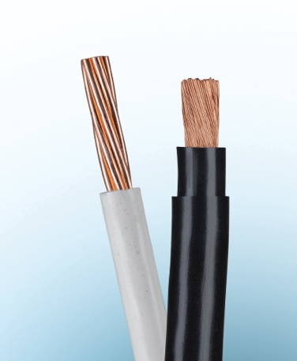
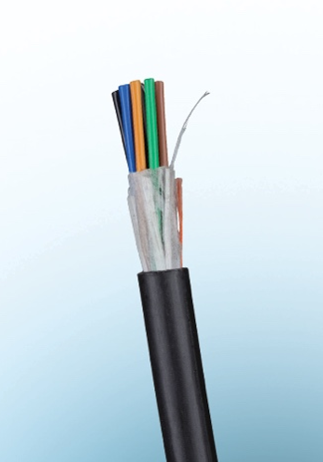

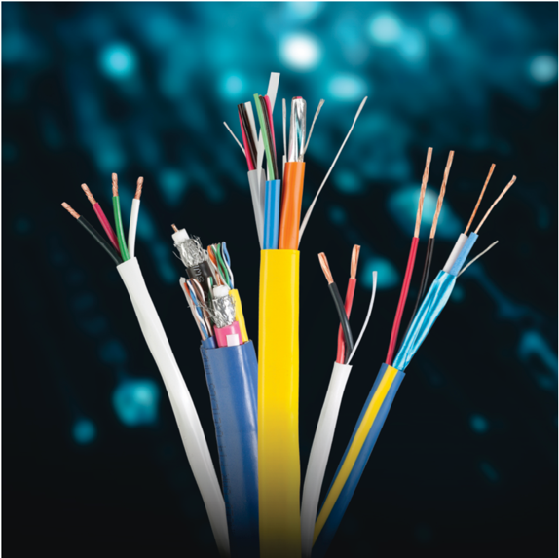

These newly engineered security cables from Remee have been designed specifically for access control technologies, such as Wiegand, the Open Supervised Device Protocol (OSDP) specification, and BACnet (a communication protocol for Building Automation and Control networks). Ideally suited for door locks, card readers In and REX, and emergency exit doors with DSM, horn/strobe and motion sensors.

PART ID | DESCRIPTION
725901L1 | WEIGAND ACCESS CONTROL COMBO CMP 500' RL
725901M1 | WEIGAND ACCESS CONTROL COMBO CMP 1000' RL
R00907L1Y | WEIGAND ACCESS CONTROL COMBO CMR 500' RL
R00907M1Y | WEIGAND ACCESS CONTROL COMBO CMR 1000' RL
R00907WBTM1B | WEIGAND ACCESS CONTROL COMBO OSP 1000' RL
725953M1V | OSDP ACCESS CONTROL COMBO 22/2P CMP 1000' RL
725937M1Y | OSDP ACCESS CONTROL COMBO CMP 1000' RL
REM182222SHPM1F | CRESTRON® CMP 1000' RL
REM182222SHLTM1OY | CRESTRON® CMR 1000' RL
LU216PM1C | LUTRON® LVBP CMP 16/2 SBC 1000' RL
LUESCPM1C | LUTRON® ESC CMP 22/5C SBC 1000' RL
LUQSCPM1WO | LUTRON® QSC CMP 22/1PSH 16/2 1000' RL
LUQSCM1OZ | LUTRON® QSC CMR 22/1PSH 16/2 1000' RL
LUQSHLPM1WN | LUTRON® QSH CMP 22/1PSH 12/2 1000' RL
LUGRX346SPM1WE | LUTRON® GRX CMP 22/1PSH 18/2 1000' RL
LUGRX346SM1OE | LUTRON® GRX CMP 22/1PSH 18/2 1000' RL
LUGRX46LPM1WO | LUTRON® GRX+ CMP 22/1PSH 12/2 18/1 1000' RL
LUGRX46LM1OO | LUTRON® GRX+ CMR 22/1PSH 12/2 18/1 1000' RL
RMMJ5AE3501564L1O | 2XCAT5 2XRG6U QUAD CMR BLUE 500' RL
RMMJ6A1564WL1O | 2XCAT6 2XRG6U QUAD CMR BLUE 500' RL
RMMS5AE+1006L3B | CAT5E, 18/2 SIAMESE CMR BLACK 500' RL
RMMS5AE+1006M1B | CAT5E, 18/2 SIAMESE CMR BLACK 1000' RL
RMMS5AE+1023L1Z | CAT5E, 16/4 SIAMESE CMR ORANGE 500' RL

Standard Plenum-rated Security Cables

The 725 Series cable offering for 300V control, instrumentation and security cable installations features Remguard Plenum Polymer insulation and jackets over stranded copper conductors. Shielded and unshielded versions are offered with a selection of AWG sizes and number of conductors.

Standard Riser-rated Security Cables

The 900 and R00 Series are Riser-Rated versions of most of the 725 series. With PVC insulation and jackets, these Riser cables are more flexible than their plenum-rated cousins.

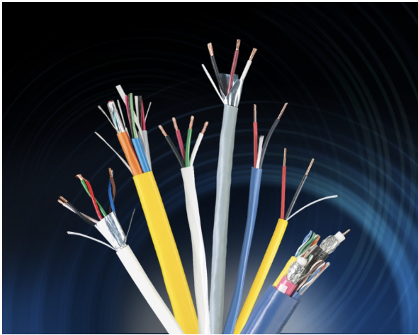
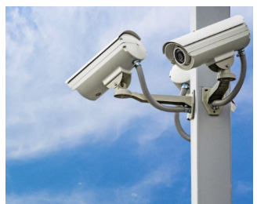
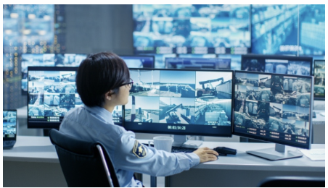
They include stranded copper conductors and a choice of shielded or unshielded versions. Also included in this series are several water blocked cables for Direct Burial use.

PART ID | DESCRIPTION
725120**W | 12/2 STR BC NS CMP WHITE 1000' RL
725140**W | 14/2 STR BC NS CMP WHITE 1000' RL
725146**W | 14/4 STR BC NS CMP WHITE 1000' RL
725160**W | 16/2 STR BC NS CMP WHITE 1000' RL
725164**W | 16/4 STR BC NS CMP WHITE 1000' RL
725180**W | 18/2 STR BC NS CMP WHITE 1000' RL
725182**W | 18/3 STR BC NS CMP WHITE 1000' RL
725184**W | 18/4 STR BC NS CMP WHITE 1000' RL
725186**W | 18/6 STR BC NS CMP WHITE 1000' RL
725188**W | 18/8 STR BC NS CMP WHITE 1000' RL
725220**W | 22/2 STR BC NS CMP WHITE 1000' RL
725224**W | 22/4 STR BC NS CMP WHITE 1000' BX
725228**W | 22/6 STR BC NS CMP WHITE 1000' RL
725121**W | 12/2 STR BC SHLD CMP WHITE 1000' RL
725141**W | 14/2 STR BC SHLD CMP WHITE 1000' RL
725161**W | 16/2 STR BC SHLD CMP WHITE 1000' RL
725181**W | 16/4 STR BC SHLD CMP WHITE 1000' RL
725183**W | 18/2 STR BC SHLD CMP WHITE 1000' RL
725163**W | 18/3 STR BC SHLD CMP WHITE 1000' RL
725185**W | 18/4 STR BC SHLD CMP WHITE 1000' RL
725187**W | 18/6 STR BC SHLD CMP WHITE 1000' RL
725189**W | 18/8 STR BC SHLD CMP WHITE 1000' RL
** = See Product Number Key on page 26

PART ID | DESCRIPTION
725221**W | 22/2 STR BC SHLD CMP WHITE 1000' RL
725223**W | 22/4 STR BC SHLD CMP WHITE 1000' RL
725227**W | 22/2PR STR BC EPS CMP WHITE 1000' BX
7252285**W | 22/6 STR BC SHLD CMP WHITE 1000' BX
R001002R/7B**G | 16/2 STR BC NS CMR GRAY 1000' RL
R001023R**G | 16/4 STR BC NS CMR GRAY 1000' RL
R001006R**G | 18/2 STR BC NS CMR GRAY 1000' BX
R001008R**G | 18/4 STR BC NS CMR GRAY 1000' BX
R0010186**G | 18/6 STR BC NS CMR GRAY 1000' RL
R001032**G | 22/2 STR BC NS CMR GRAY 1000' BX
R001034**G | 22/4 STR BC NS CMR GRAY 1000' BX
R001036**G | 22/6 STR BC NS CMR GRAY 1000' BX
900902**G | 16/2 STR BC SHLD CMR GRAY 1000' RL
900912R**G | 18/2 STR BC SHLD CMR GRAY 1000' RL
900913**G | 18/3 STR BC SHLD CMR GRAY 1000' RL
900914**G | 18/4 STR BC SHLD CMR GRAY 1000' RL
900916** | 18/6 STR BC SHLD CMR GRAY 1000' RL
900942R**G | 22/2 STR BC SHLD CMR GRAY 1000' BX
900944R**G | 22/4 STR BC SHLD CMR GRAY 1000' BX
900946R**G | 22/6 STR BC SHLD CMR GRAY 1000' BX
900948**G | 22/8 STR BC SHLD CMR GRAY 1000' RL
** = See Product Number Key on page 26

Fire alarm systems serve as a lifeline and a connection to first responders.
When a signal is transmitted to central monitoring center, failure is not an option. It must be
guaranteed. Conventional Fire Alarm Systems have been around for many years and have
changed little. They provide well proven technology protecting many hundreds of thousands
of properties worldwide. Remee fire alarm cables are backed with our 50+ years of
manufacturing experience in our New York facility. All Remee Fire Alarm Cables are ETL
listed and manufactured under ISO 9001 certification.

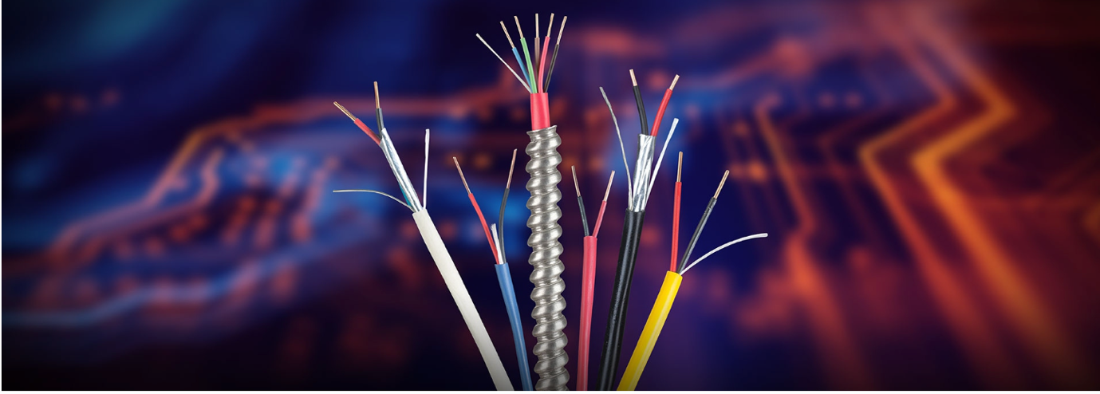

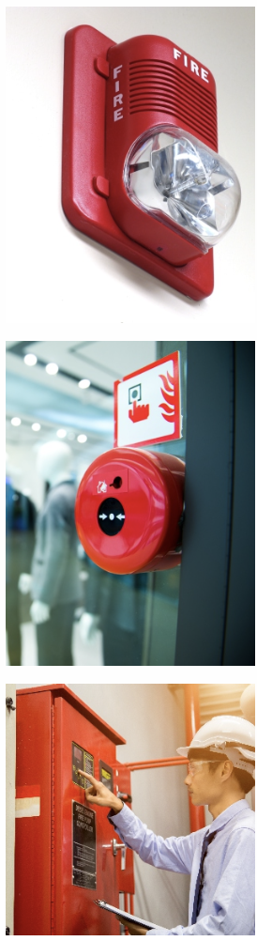
PART ID | DESCRIPTION
760184**R | 18/4 SBC NS FPLP RED 1000' RL
760180**R | 18/2 SBC NS FPLP RED 1000' RL
760160**R | 16/2 SBC NS FPLP RED 1000' RL
760164**R | 16/4 SBC NS FPLP RED 1000' RL
760140**R | 14/2 SBC NS FPLP RED 1000' RL
760144**R | 14/4 SBC NS FPLP RED 1000' RL
760120**R | 12/2 SBC NS FPLP RED 1000' RL
760181**R | 18/2 SBC SHLD FPLP RED 1000' RL
760185**R | 18/4 SBC SHLD FPLP RED 1000' RL
760161**R | 16/2 SBC SHLD FPLP RED 1000' RL
760141**R | 14/2 SBC SHLD FPLP RED 1000' RL
760121**R | 12/2 SBC SHLD FPLP RED 1000' RL
R00404**R | 22/4 SBC NS FLPR RED 1000' BX
R00293**R | 18/2 SBC NS FPLR RED 1000' RL
R00294**R | 18/4 SBC NS FPLR RED 1000' RL
R00296**R | 18/6 SBC NS FPLR RED 1000' RL
R00301**R | 16/2 SBC NS FPLR RED 1000' RL
R00302**R | 16/4 SBC NS FPLR RED 1000' RL
R00305**R | 14/2 SBC NS FPLR RED 1000' RL
R00317**R | 12/2 SBC NS FLPR RED 1000' RL
R00310**R | 18/2 SBC SHLD FPLR RED 1000' RL
R00303**R | 16/2 SBC SHLD FPLR RED 1000' RL
R00304**R | 16/4 SBC SHLD FPLR RED 1000' RL
R00306**R | 14/2 SBC SHLD FPLR RED 1000' RL
R00308**R | 14/4 SBC SHLD FPLR RED 1000' RL
** = See Product Number Key on page 26

Remee manufactures Fire Alarm Cables to meet the specifications of municipalities,
including NYC Local Law 39 (LL39) Fire Alarm requirements.

PART ID | DESCRIPTION
NY516UH**R | 16/1PR SOL BC NY5 FA 150D FPLP RD 1000FT
NY516SH**R | 16/1PR SOL BC NY5FA 150D SH FPLP RD 1000
NY514UH**R | 14/1PR SOL BC NY5FA 150D FPLP RD 1000' R
NY514SH**R | 14/1PR SOL BC NY5FA 150D SH FPLP RD 1000
NY512UH**R | 12/2 SOL BC NY5 FA 150D FPLP RD 1000FT
NY512SH**R | 12/2 SH SOL BC NY5 FA 150D FPLP RD 1000
NY164CUH**R | 16 4C SOL BC NY5 FA 150D FPLP RD 1000FT
NY164CSH**R | 16 4C SOL BC NY5FA 150D SH FPLP RD 1000
NY144CUH**R | 14/4 SOL BC NY5 FA 150D FPLP RD 1000
NY144CSH**R | 14 4C SOL BC NY5FA 150D SH FPLP RD 1000
NY514UT**R | 14/1PR SOL BC NY5 FA 200D FPLP RD 1000FT
NY14PUT**R | 14/2PR SOL BC NY5 FA 200D FPLP RD 1000
NY516UT**R | 16/1PR SOL BC NY5 FA 200D FPLP RD 1000FT
NY16PUT**R | 16/2PR SOL BC NY5 FA 200D FPLP RD 1000FT
NY512ST**R | 12/1P SOL BC SHLD NY5FA 200D RD 1000' RL
NY514ST**R | 14/1PR SOL BC NY5FA 200D SH FPLP RD 1000
NY14PST**R | 14/2PR SOL BC NY5FA 200D SH FPLP RD 1000
NY516ST**R | 16/1P SOLBC SHLD NY5FA 200D RD 1000' RL
NY16PST**R | 16/2P SOLBC SHLD NY5FA 200D RD 1000' RL
** = See Product Number Key on page 26

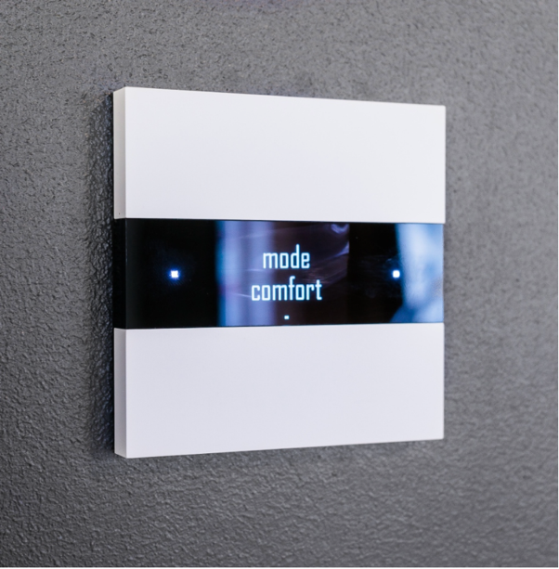

A thermostat is a regulating device component which senses the temperature of a physical system and performs actions so that the system’s temperature is maintained near a desired setpoint. Thermostats are used in any device or system that heats or cools to a set temperature point.

PART ID | DESCRIPTION
182THPL1N | 18/2 SBC BRW TSTAT CMP 4 X 500' RL/BO
183THPL1N | 18/3 SBC BRW TSTAT CMP 4 X 500' RL/BO
184THPT1N | 18/4 SBC BRW TSTAT CMP 4 X 250' RL/BO
185THPT1N | 18/5 SBC BRW TSTAT CMP 4 X 250' RL/BO
186THPT1N | 18/6 SBC BRW TSTAT CMP 4 X 250' RL/BO
188THPT1N | 18/8 SBC BRW TSTAT CMP 2 X 250' RL/BO
182THL1N | 18/2 SBC BRW TSTAT CMP 4 X 500' RL/BO
183THL1N | 18/3 SBC BRW TSTAT CMR 4 X 500' RL/BO
184THT1N | 18/4 SBC BRW TSTAT CMR 4 X 250' RL/BO
185THT1N | 18/5 SBC BRW TSTAT CMR 4 X 250' RL/BO
186THT1N | 18/6 SBC BRW TSTAT CMR 4 X 250' RL/BO
188THT1N | 18/8 SBC BRW TSTAT CMR 2 X 250' RL/BO
1810THT1N | 18/10 SBC BRW TSTAT CMR 2 X 250' RL/BO
202THL1N | 20/2 SBC BRW TSTAT CMR 4 X 500' RL/BO
204THT1N | 20/4 SBC BRW TSTAT CMR 4 X 250' RL/BO

Remee manufactures a large variety of cable. Our fiber optic cable offering includes:

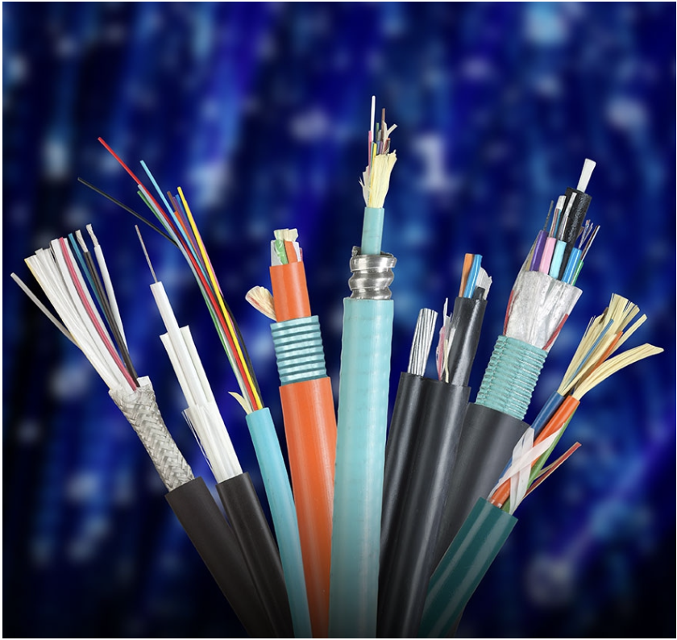
Our broad selection includes the following fiber optic cable types:
- Loose Tube
- RemCoreTM – MicroTube cables
- Tight Buffered
- General Purpose
- Distribution
- Breakout cable
- Single Mode
- Multimode
- Simplex
- Duplex
- Indoor & outdoor fiber optic cable
- Combinations of the above

Remee also produces fiber optic cables featuring:
- Armored & unarmored configurations
- Polyethylene, Low Smoke Zero Halogen & PVC jacket types
- 2 – 288 fibers
- Single mode, Multimode, OM3 & OM4 configurations
- 10 GIG fiber types
- AquaLock® dry tube technology for loose tube fiber
- Standard gel filled options
- Plenum fiber optic cable

Remee’s new AquaLock® loose tube technology ensures a dry tube.

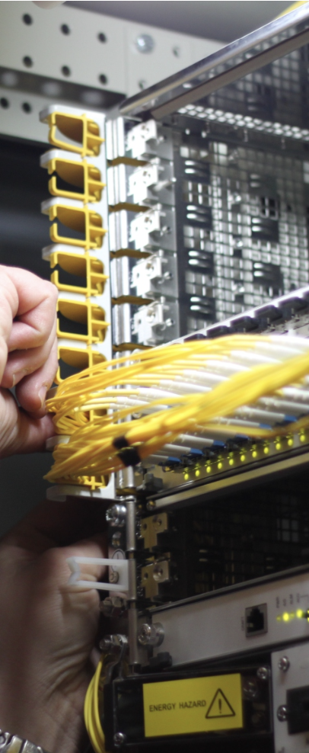
PART ID | DESCRIPTION
33-006-76B-RYNOOP | 6F SM OS2 DIST I/O YELLOW OFNP
33-012-76B-RYNOOP | 12F SM OS2 DIST I/O YELLOW OFNP
33-024-76B-RYNOOP | 24F SM OS2 DIST I/O YELLOW OFNP
33-006-22J-RZNOOP | 6F OM1 DIST I/O ORANGE OFNP
33-012-22J-RZNOOP | 12F OM1 DIST I/O ORANGE OFNP
33-024-22J-RZNOOP | 24F OM1 DIST I/O ORANGE OFNP
33-006-12L-RANOOP | 6F OM3 DIST I/O AQUA OFNP
33-012-12L-RANOOP | 12F OM3 DIST I/O AQUA OFNP
33-024-12L-RANOOP | 24F OM3 DIST I/O AQUA OFNP
33-006-12V-RMNOOP | 6F OM4 DIST I/O MAGENTA OFNP
33-012-12V-RMNOOP | 12F OM4 DIST I/O MAGENTA OFNP
33-024-12V-RMNOOP | 24F OM4 DIST I/O MARGENTA OFNP
REMEX330676BYIALR | 6F SM OS2 DIST I/O YELLOW OFCP - IAL
REMEX331276BYIALR | 12F SM OS2 DIST I/O YELLOW OFCP - IAL
REMEX332476BYIALR | 24F SM OS2 DIST I/O YELLOW OFCP - IAL
REMEX330622JZIALR | 6F OM1 DIST I/O ORANGE OFCP - IAL
REMEX331222JZIALR | 12F OM1 DIST I/O ORANGE OFCP - IAL
REMEX332422JZYIALR | 24F OM1 DIST I/O ORANGE OFCP - IAL
REMEX330612LAIALR | 6F OM3 DIST I/O AQUA OFCP - IAL
REMEX331212LAIALR | 12F OM3 DIST I/O AQUA OFCP - IAL
REMEX332412LAIALR | 24F OM3 DIST I/O AQUA OFCP - IAL
REMEX330612VAIALR | 6F OM4 DIST I/O MAGENTA OFCP - IAL
REMEX331212VAIALR | 12F OM4 DIST I/O MAGENTA OFCP - IAL
REMEX332412VMIALR | 24F OM4 DIST I/O MAGENTA OFCP - IAL

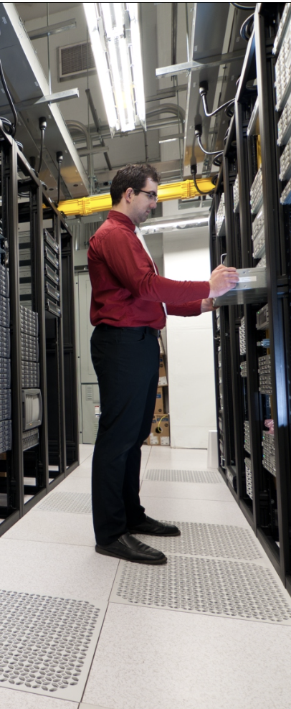
PART ID | DESCRIPTION
54-006-22J-EBCFNN | 6F OM1 UNITUBE SA/SJ
54-012-22J-ENCLNN | 12F OM1 UNITUBE SA/SJ
54-006-76B-EBCFNN | 6F SM OS2 UNITUBE SA/SJ
54-012-76B-EBCLNN | 12F SM OS2 UNITBUE SA/SJ
54-006-22J-EBCFNN | 6F OM1 UNITUBE SA/SJ
54-012-22J-ENCLNN | 12F OM1 UNITUBE SA/SJ
54-006-76B-EBCFNN | 6F SM OS2 UNITUBE SA/SJ
54-012-76B-EBCLNN | 12F SM OS2 UNITBUE SA/SJ

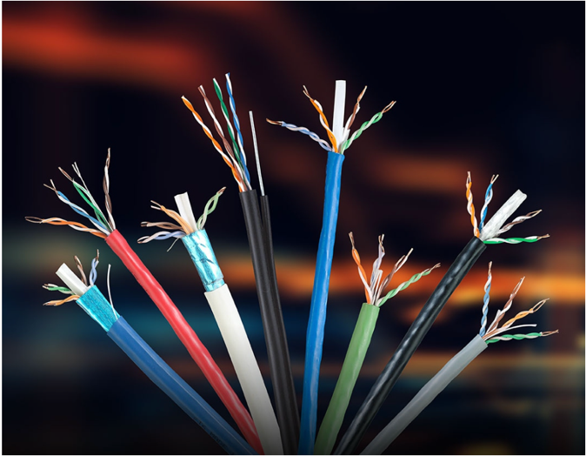

Our LAN & Premise Cables provide robust solutions for commercial enterprise networks to connect people, information and technology. Typically constructed with twisted pairs, premise cables provide performance up to 10 Gigabit Ethernet and beyond.

PART ID | DESCRIPTION
6UB234STPM1 | CAT6A STP CMP 1000' RL
6UA234STPM1 | CAT6A STP CMR 1000' RL
6UBRD234UTPM1 | CAT6A UTP CMP 1000' RL
6UARD234UTPRM1 | CAT6A UTP CMR 1000' RL
6B234STPENHM1 | CAT6 STP CMP 1000' RL
6BNSM2O | CAT6 UTP CMP 1000' BX
6B234UTPENHM1 | CAT6+ UTP CMP 1000' RL
6RF234STPENHM1 | CAT6 STP CMR 1000' RL
6RF234UTPM1 | CAT6+ UTP CMR 1000' RL
6RNSM2 | CAT6 UTP CMR 1000' BX
6BNS224LP5M1 | CAT6 UTP LP CMP 1000' RL
5BE234STPM1 | CAT5E 350MHz STP CMP 1000' RL
5BE244UTP/350M2 | CAT5E 350MHz UTP CMP 1000' BX
5AE244STPM1 | CAT5E 350MHz STP CMR 1000' RL
5AE244UTPRM2 | CAT5E 350MHz UTP CMR 1000' BX

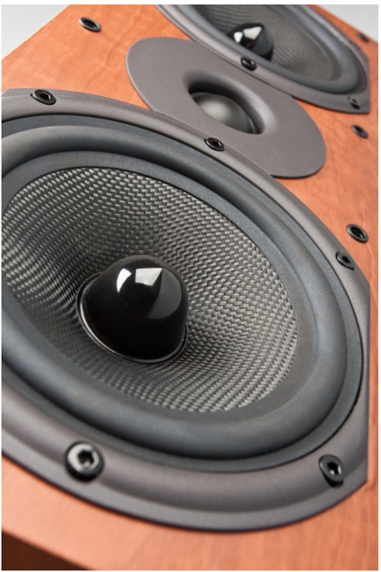
This perfectly balanced speaker wire makes our product one of the best the in audiophile and
high fidelity worlds.

Manufactured with the high-strand copper, Remee’s speaker wire is the high-end solution for any modern sound system.

PART ID | DESCRIPTION
CH1026M1W | 12/2 105 STR BC SPKR CMR WHITE 1000' RL
CH1002FL2W | 16/2 65 STR BC SPKR CMR WHITE 500' BX
CH1002FM2W | 16/2 65 STR BC SPKR CMR WHITE 1000' BX
CH1023FL2W | 16/4 65 STR BC SPKR CMR WHITE 500' BX
CH1023FM2W | 16/4 65 STR BC SPKR CMR WHITE 1000' BX
CH1000FL2W | 14/2 105 STR BC SPKR CMR WHITE 500' BX
CH1000FM2W | 14/2 105 STR BC SPKR CMR WHITE 1000' BX
CH1024FL2W | 14/4 105 STR BC SPKR CMR WHITE 500' BX
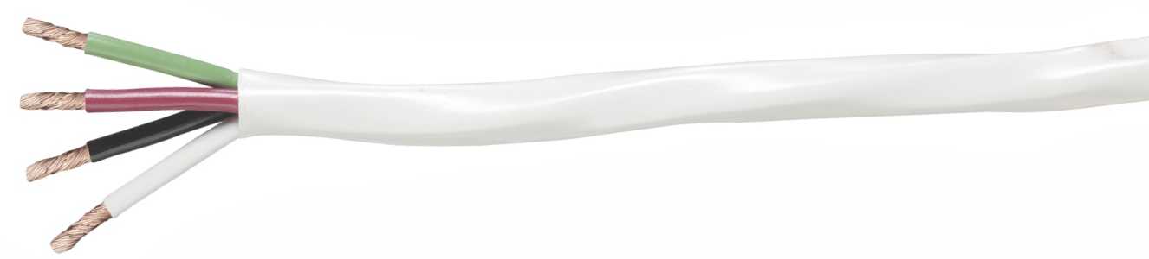

Wet Location copper cables must be durable and able to withstand severe environmental conditions. Outside Plant cables are often exposed to oil, heat, cold, moisture as well as numerous chemicals. Wet Location, OSP and buried cables are required to stand up against impact, remain flexible and maintain signal integrity.

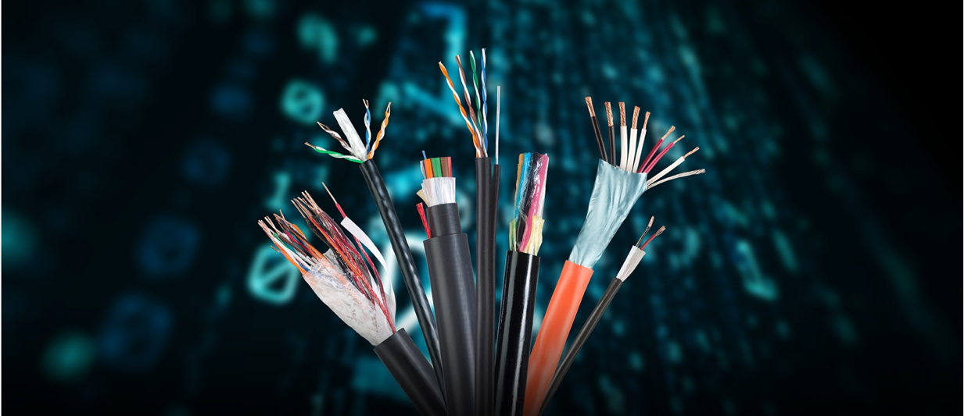

PART ID | DESCRIPTION
6DBFLD234UTPM1B | CAT6 UTP FLD OSP POLY BLACK 1000' RL
6DBFLD234UTPMESSM1B | CAT6 UTP FLD OSP MESS BLACK 1000' RL
5AEFLDM1B | CAT5E UTP FLD OSP POLY BLACK 1000' RL
5AEFLDMESSM1B | CAT5E UTP FLD OSP MESS POLY BLACK 1000' RL
5AE350STP/POLYM1B | CAT5E UTP STP OSP BLACK 1000' RL
R001006WBTPOLYM1B | 18/2 STR BC NS OSP WBT POLY BLACK 1000' RL
R001008WBTPOLYM1B | 18/4 STR BC NS OSP WBT POLY BLACK 1000' BX
900912WBTPOLYM1B | 18/2 STR BC SHLD OSP WBT POLY BLACK 1000' RL
900916WBTPOLYM1B | 18/6 STR BC SHLD OSP WBT POLY BLACK 1000' RL
R001567M1B | RG6/U 60% ALUM BRAID FLD POLY BLACK 1000' RL
R001531WBTPOLYM1B | RG6/U 60% CCA BRAID WBT POLY BLACK 1000' RL
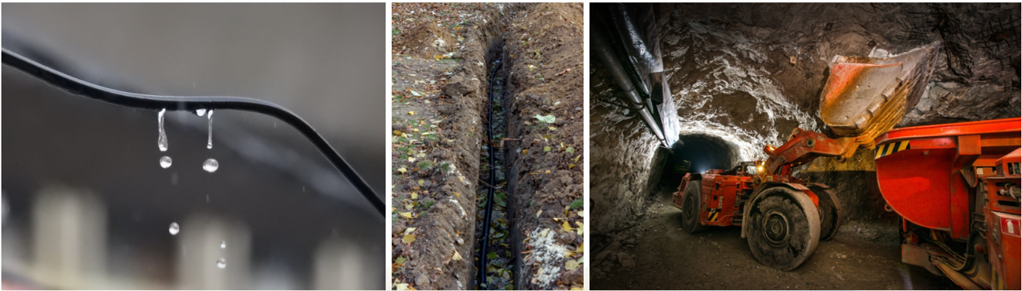

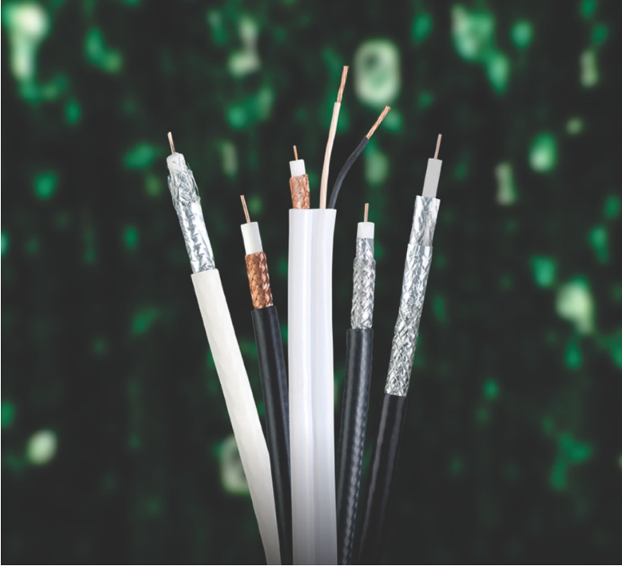
Coaxial cables have an advantage
over other types of cables.
In an ideal coaxial cable, the signal
exists only in the space between
the inner and outer conductors.
This allows coaxial cables to be
installed next to metal objects,
such as gutters, without the power
losses that occur in other types
of cables. Coax cables with multiple
shields have less leakage.
This property allows the cable to
carry weaker signals with less
interference from the outside
environment.
Remee Wire & Cable offers both
indoor & outdoor copper coax cable.

PART ID | DESCRIPTION
725107M1W | RG11/U 60% AL BRAID CMP WHITE 1000' RL
725109M1W | RG11/U 60%/40% AL BRAID CMP WHITE 1000' RL
R001586RM1B | RG11/U 60% AL BRAID CMR BLACK 1000' RL
725103M1W | RG6/U 60%/40% AL BRAID CMP WHITE 1,000' RL
R001564WRM2 | RG6/U 60%/40% AL BRAID CMR BLACK 1000' BX
725105/60M1W | RG6/U 60% AL BRAID CMP WHITE 1000' RL
R001563WRM2 | RG6/U 60% AL BRAID CMR BLACK 1000' BX
725105/95BCM1W | RG6/U 95% BC BRAID CMP WHITE 1000' RL
R001536M1B | RG6/U 95% CCA BRAID + 18/2 CMR BLACK 1000' RL
725536M1W | RG6/U 95% BC BRAID + 18/2 CMP WHITE 1000' RL

LENGTHS | PACKAGING  IDENTIFICATION |  | COLORS
M 1000 Ft.  L 500 Ft.  T 250 Ft.  C 100 Ft.  D 50 Ft.  O 25 Ft.  ME Length other than  500 Ft. or 1000 Ft.  BU Length over 1000 Ft.  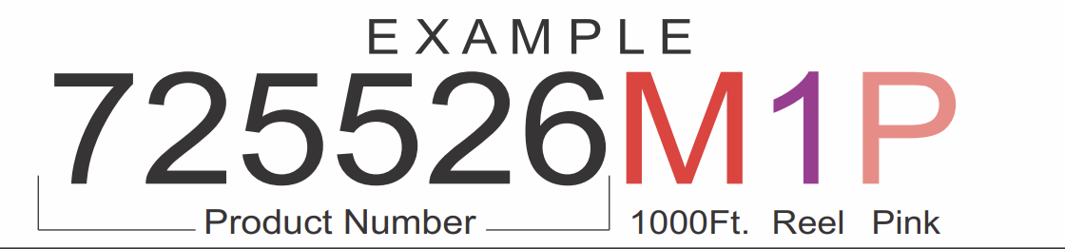 | 1 Reel  2 Coil in Box  3 Reel in Box  4 Coil Bag | O Blue  W White  G Grey  E Green  Y Yellow  R Red  Z Orange  V Violet/Purple  P Pink  T Tan/Beige  B Black

While Remee Products Corp. has made every reasonable effort to ensure the accuracy of the information in this document, Remee Products Corp. does not guarantee that it is error-free, nor does Remee Products Corp. make any other representation, warranty, or guarantee that the information is accurate, correct, reliable or current. Remee Products Corp. reserves the right to make any adjustments to the information contained herein at any time without notice. Remee Products Corp. expressly dis-claims all implied warranties regarding the information contained herein, including but not limited to, any implied warranties of merchantability or fitness for particular purpose. The dimensions in this document are for reference purposes only and are subject to change without notice.

Remee Products Corporation, dba Remee Wire & Cable, and any other affiliated companies claim and reserve all rights to graphic images and text, trade names and trademarks, logos, service names, and similar proprietary marks, and any other intellectual property rights associated with this and other publications. “Remee Wire & Cable” and other distinctive identifiers of Remee Products Corporation and its affiliated companies as used herein are or may be pending or registered or unregistered trademarks of Remee Products Corporation, or its affiliates, in the United States and/or other jurisdictions throughout the world. Remee’s trade names, trademarks, logos, service names, and similar proprietary marks shall not be reprinted or displayed without Remee’s permission and/or in any form inconsistent with Remee’s business interests. Remee reserves the right to demand the discontinuation of any improper use at any time.

© 2024, Remee Products Corporation, Florida, NY, dba Remee Wire & Cable

